Making a connector cable for GPS

The survey grade antenna and the K503 GPS use N style connectors and I use LMR 195 cable

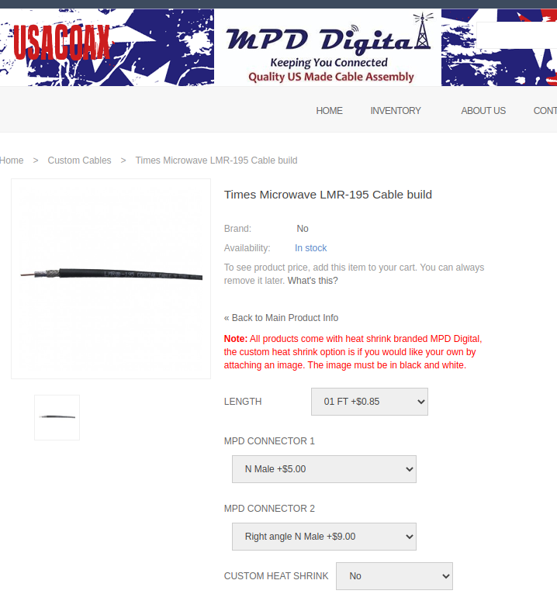

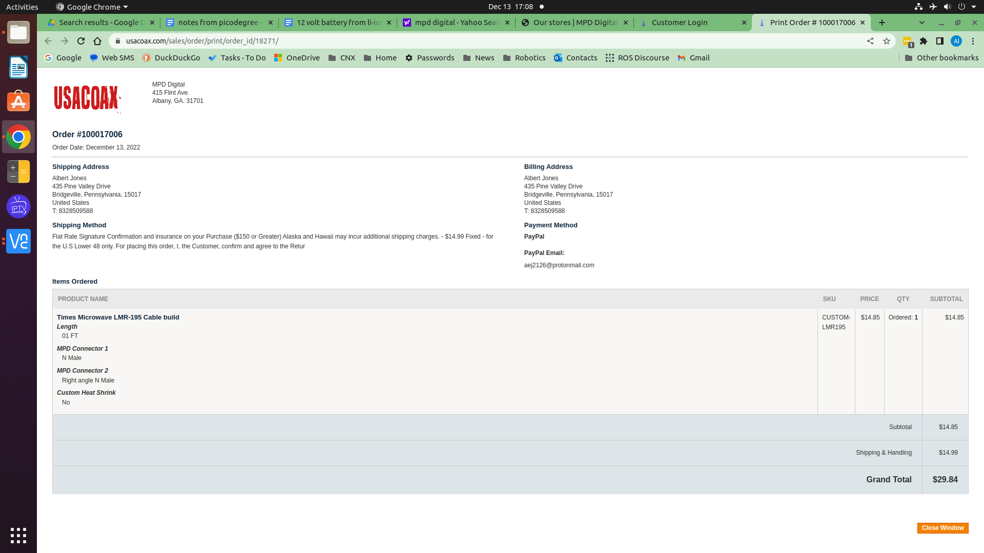

https://usacoax.com/custom/custom-lmr195-cable-build.html

